**Foodaholic**

**UI Prototype**

**TABLE OF CONTENTS**

**Main Screen** **1**

**View Detail Post Screen** **2**

**Create and Post new recipe** **4**

**User bar** **6**

**List of my post** **7**

**Report post** **8**

**Search Recipes** **9**

**Report list of the admin account** **10**

Handle reported post 10

Handle reported account10

**Sign in, Sign up** **11**

**Profile Screen** **11**

# **Main Screen**

This is the main screen where the user if user successfully logged in will be redirected here.

To access again to this page, user can click “Home” on the navigation bar on the top of the page. The main screen will display the most recent posts in the "New dishes" section or the most interactive posts in the "Trending" section.

User can click “View” button on each post to view this post's specifics (will be covered later)

The search bar on this screen allows users to look up recipes by dish name or ingredient. (will be covered in detail later).

“Post something new” button help users create and share posts on the website.

# **View Detail Post Screen**

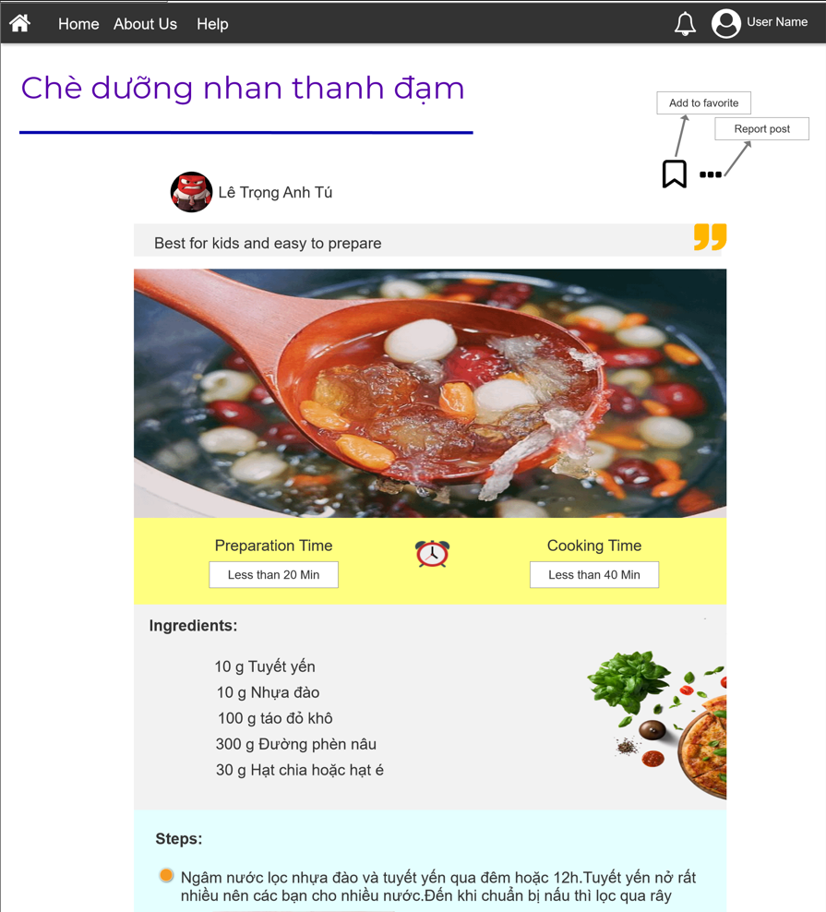

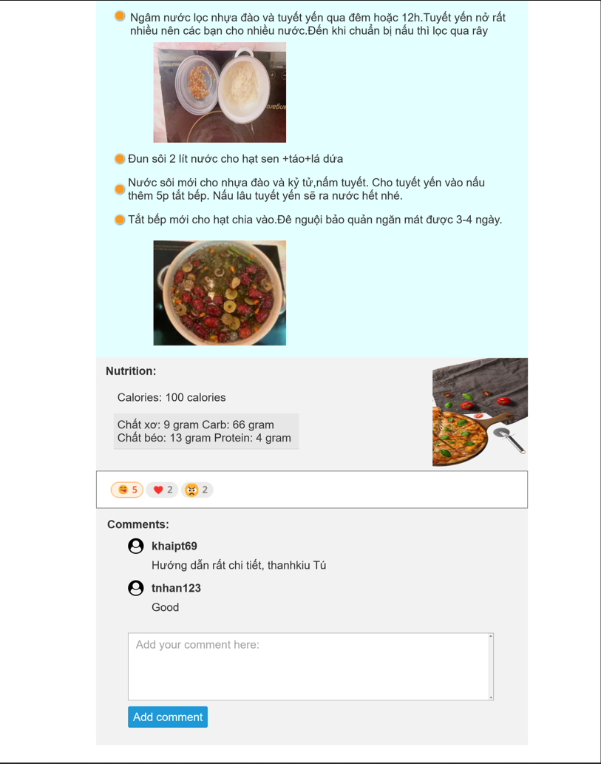

Users will see post details (like the image above) when clicking the "View" button at any post on the main screen.

Here, the user may view the entire dish's details including name of dish, name of poster, image of dish, ingredients, detail step, nutrition values, etc.

In addition to viewing, users can interact with this post by “Add to favorite” or report violated post on the right corner of the post. Or give emoji and comment on this post.

# **Create and Post new recipe**

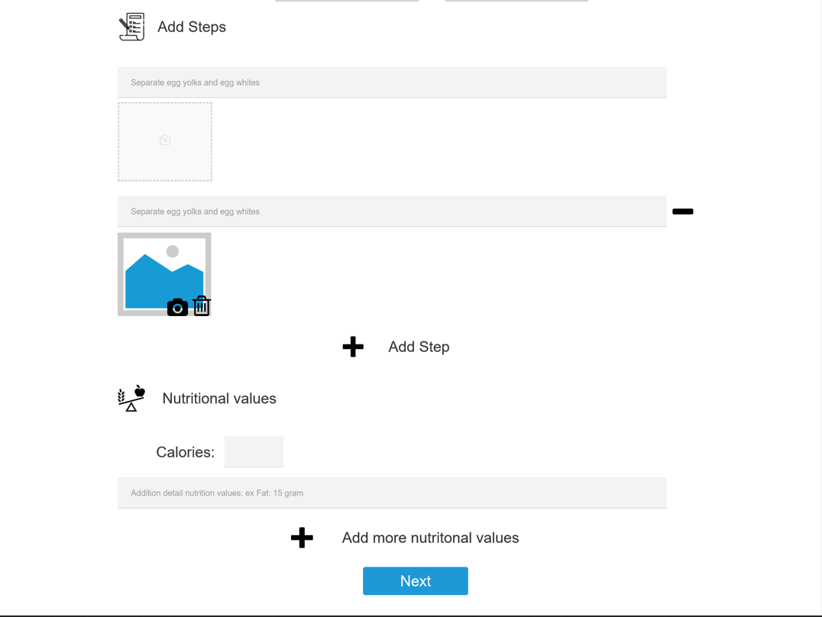

Clicking “Post something new” on main screen, user will be directed to this page.

The user will have to enter the information of the dish such as recipe name, short description about this dish.

In the “Ingredients” field, default and will have at least 1 element. User can add more ingredients by clicking “Add ingredient” right below.

The same as the "Ingredients" field, default of step is 1 and user can add more by clicking the “Add step” button. User can insert image on each step by a “square with camera symbol” and choose the path of picture.

After image inserted, in the bottom right of picture will show 2 icon to help user replace image or delete this image

“Calorie” is a required field to enter in “Nutritional values”, user can add more by clicking “Add more nutritional values”

After entering all the required fields, the user clicks next to move to the final step of choosing a thumbnail for the dish.

The final step is to choose the background image for the dish, which should be the image of the dish after it is completed. This is also the image displayed on the main screen.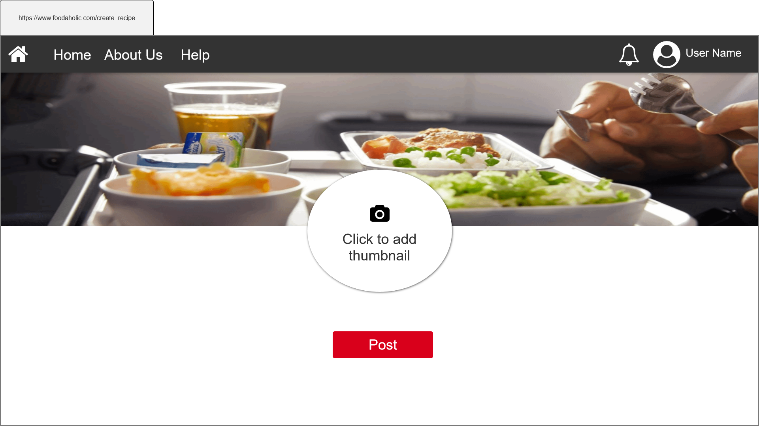

# **User bar**

The user bar will be displayed when the user clicks on the avatar in the upper right corner.

It helps users to access the page to change personal information, account information, see posts of users like, comment or list of user’s posts and log out.

# **List of my post**

This page will display the posts that the user has posted in chronological order (most recent shows first). Users can click on the name of the dish to see the details of that dish. Click “See more” button for the site to show more posts

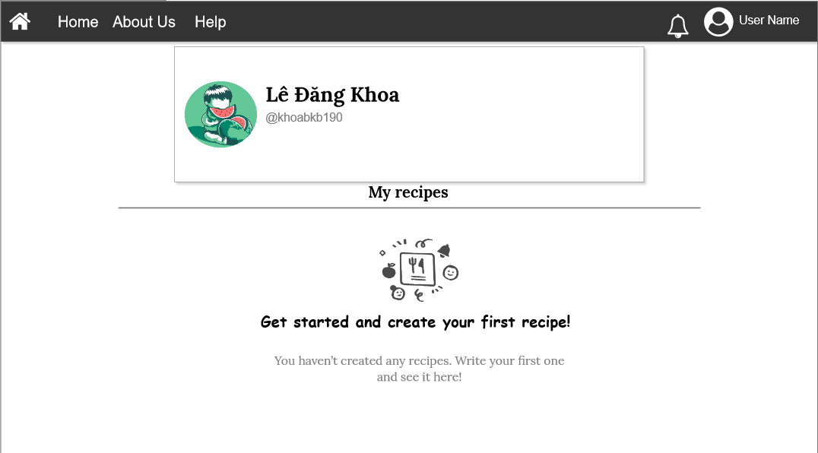

If users haven’t posted anything yet, this screen will be displayed

# **Report post/ account**

This notice board will appear if user reports another's post or account. By clicking the arrow to the right, the user can select the issue with this post/account that was violated.

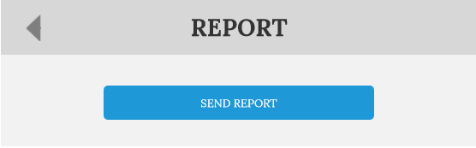

Then this board will be displayed to confirm the user is certain that they wish to submit the report.

# **Search Recipes**

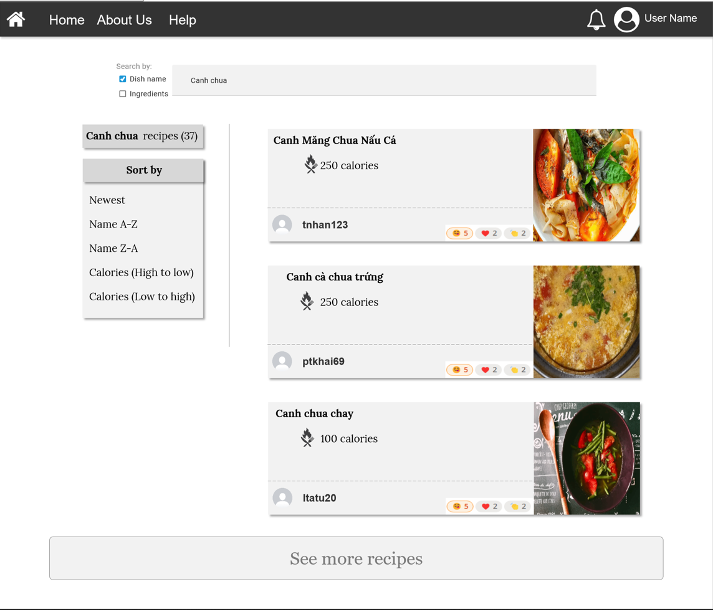

User can search post recipes via search bar in main page by typing ingredients names that are separated by commas (‘,’) or name of dish.

The screen will display the posts with the closest keyword to the keyword to search as well as the number of posts returned. Users can view this post in greater detail by clicking on it.

A box named “Sort by” in the left helps user can sort the search results by datetime, alphabet order or sort by calories in nutrition values of dish

# **Report list of the admin account**

## **Handle reported post**

By clicking on the ID of the reported post, the admin can read the post's details. Then decide if the post violates the same standards as the report describes and choose action.

After the decision is made, a notice will be sent to both the reporter and the person being reported

## **Handle reported account**

Similar to the handling of the reported post. In addition, if the account violates the terms, the admin needs to choose the period of time to suspend the account.

# **Sign in, Sign up**

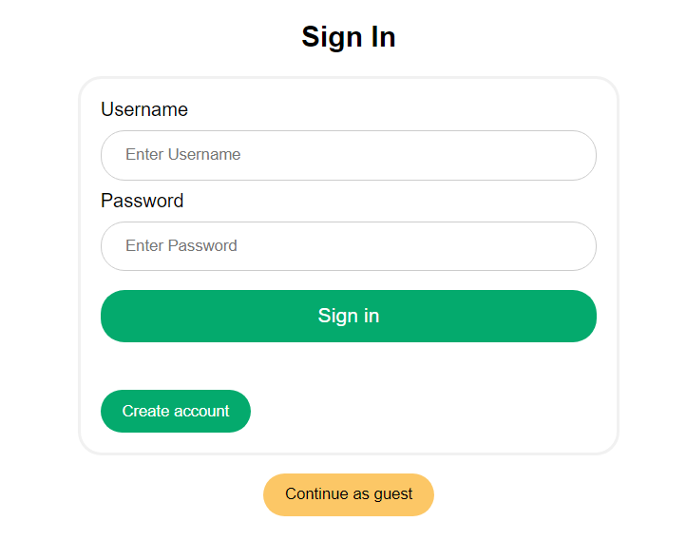

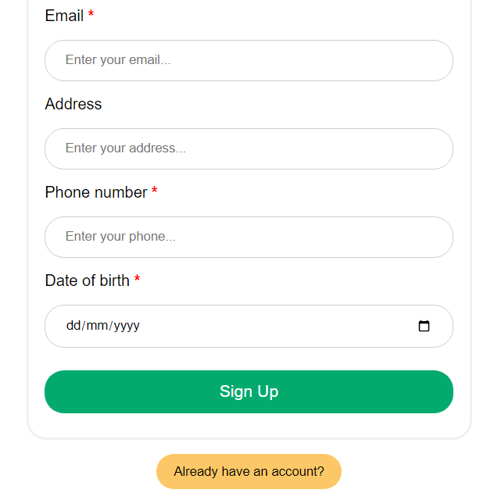

In the “Sign in” page, the user can fill two fields Username and Password of their account if they have already registered. Or users can click “Create account” to register a new account for themself.

In another way, users can click “Continue as guest” to enter homepage without login, but it will limit some features

In the “Sign up” page, the user must fill all fields with the “*” symbol, this is the compulsory field. After that, users click “Sign up” button to complete the registration process. Or they can click “Already have an account?” to comeback the “Sign in” screen

# **Profile Screen**

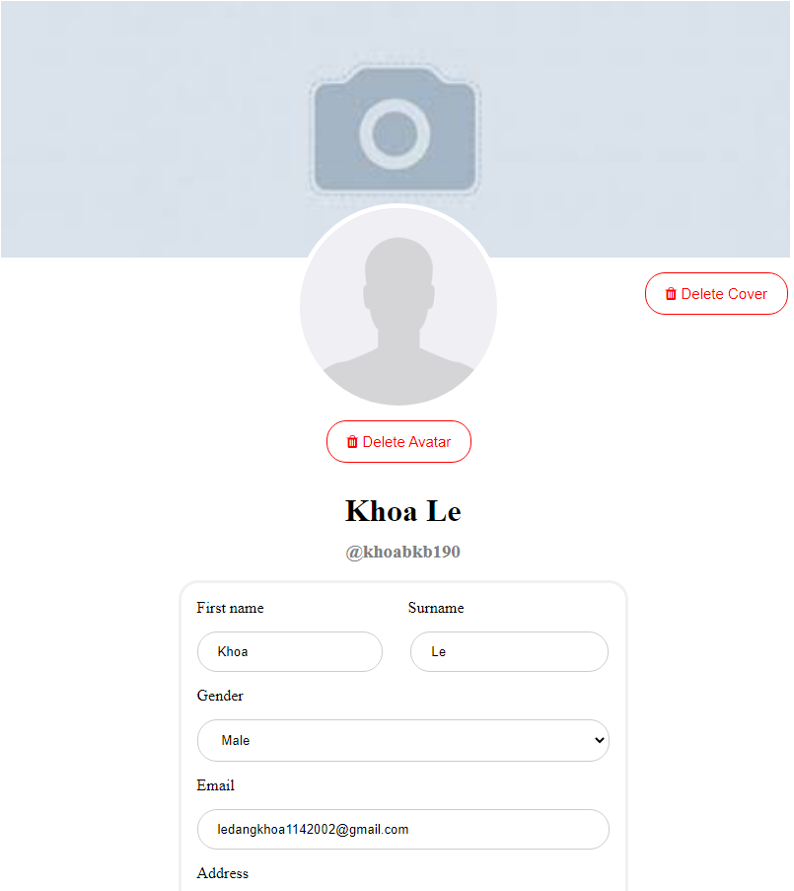

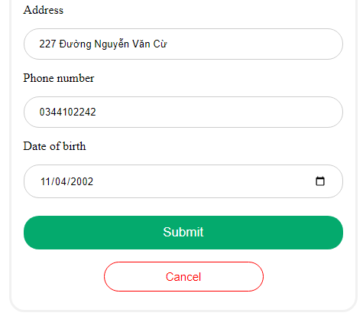

In this screen, users can see their information which they filled during the registration process. They can edit their information and press “Submit” to save.

Clicking the avatar to change this. Similar to change cover image